Name: Alison Zeng

SQL SELECT, WHERE, DISTINCT practice

1. Write a select statement to return all columns and rows from the customer table.

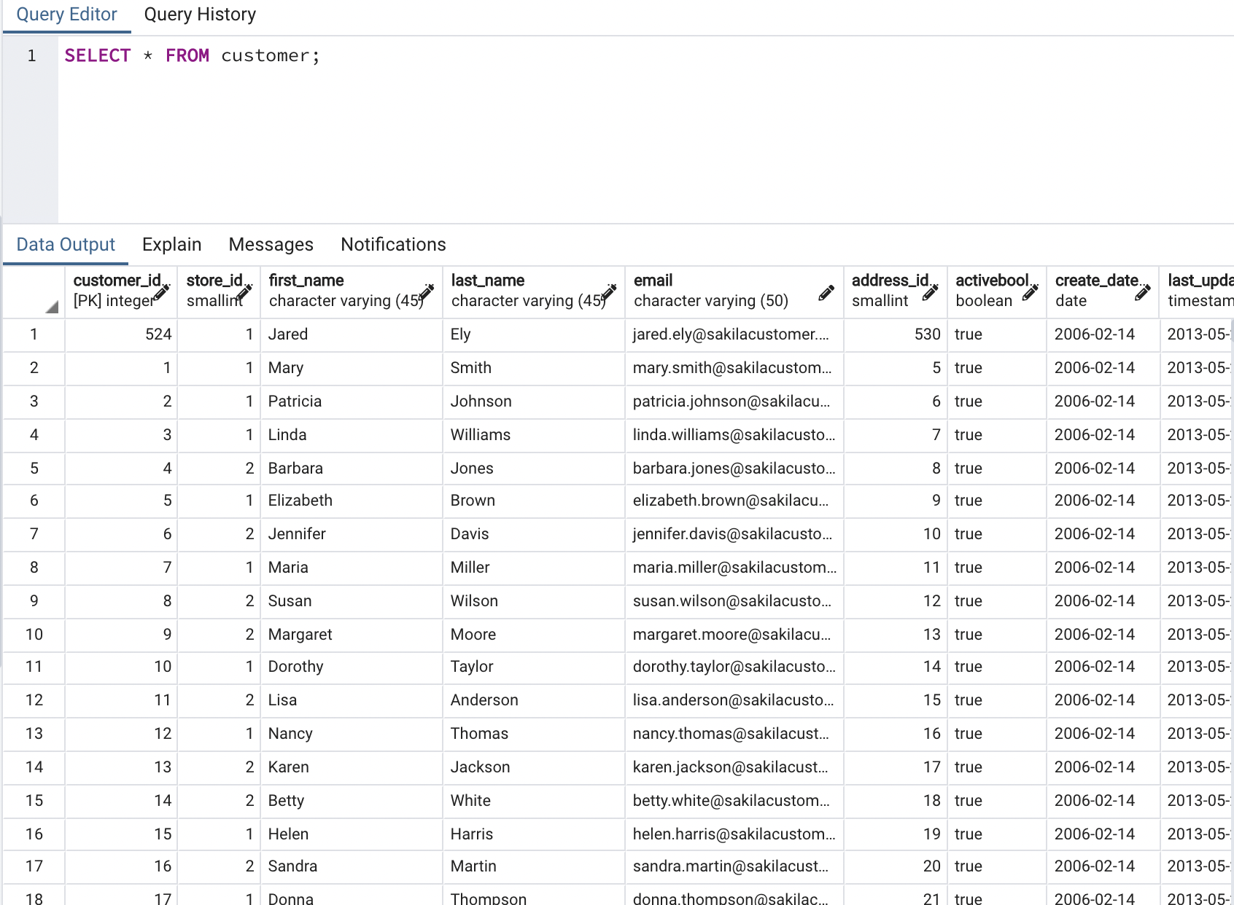

1. Write a query to select first name, last name, and email from the customer table.

1. Write a query to return all rows and columns from the film table.

1. Write a query to return unique rows from the release_year column in the film table.

1. Write a query to return unique rows from the rental_rate column in the film table.

1. A customer left us some feedback about our store. Write a query to find her email address – for Nancy Thomas.

1. We’re trying to find a customer located at a certain address ‘259 Ipoh Drive’ – can you find their phone number?

1. Write a query from the customer table, where store id is 1 and address id is greater than 150.

1. Write a query from the payment table where the amount is either 4.99 or 1.99.

1. Write a query to return a list of transactions from the payment table where the amount is greater than 5.

